34.92: a) 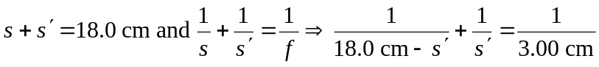
So the screen must either be 3.80 cm or 14.2 cm from the object.
b) 